**HR ANALYSIS REPORT**

1. **Total number of employees recorded:**

SELECT count(*) AS Total_Emplyee FROM hr.hr_analytics;

1. **Total number of employees attrition:**

SELECT count(Attrition) AS Total_NotAttrition_Employee FROM hr_analytics  
where Attrition='Yes'



1. **Total number of employees not attrition:**

SELECT count(Attrition) AS Total_NotAttrition_Employee FROM hr_analytics  
where Attrition='No'



1. **Show how many employees’ attrition also include no of male and female employee attrition from the company:**

SELECT

(select count(Attrition) FROM hr_analytics

where Attrition='Yes') AS Total_Attrition_Employee,

(select count(Attrition) FROM hr_analytics

where Attrition='Yes' and Gender='Female') AS Total_Female_Attrition_Employee,

(select count(Attrition) FROM hr_analytics

where Attrition='Yes' and Gender='Male') AS Total_Male_Attrition_Employee



1. **Show total no of attrition with respect to department:**

SELECT department, count(Attrition) AS Attrition_by_Departments from hr_analytics

where Attrition='Yes'

group by Department;

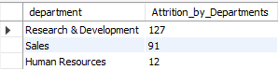

1. **Show total no of attrition with respect to education fields:**

SELECT EducationField, count(Attrition) AS Attrition_by_EducationField from hr_analytics

where Attrition='Yes'

group by EducationField;

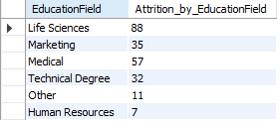

1. **Show total no of attrition with respect to age groups:**

SELECT AgeGroup, count(Attrition) AS Attririon_by_AgeGroups from hr_analytics

group by AgeGroup;

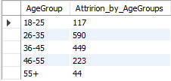

1. **Show total no of attrition with respect to departments and gender and age groups:**

SELECT Department, AgeGroup,

(SELECT COUNT(gender) FROM hr_analytics WHERE Gender = 'Female' AND Attrition= 'Yes' AND AgeGroup = main.AgeGroup AND Department = main.Department) AS Female_Attrition,

(SELECT COUNT(gender) FROM hr_analytics WHERE Gender = 'Male' AND Attrition= 'Yes' AND AgeGroup = main.AgeGroup AND AgeGroup = main.Department) AS Male_Attrition

FROM hr_analytics main

GROUP BY Department, AgeGroup;

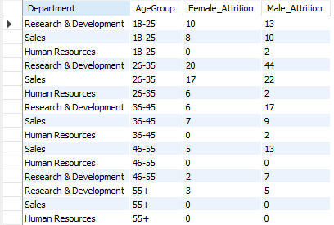

1. **Show total no of attrition with respect to education fields and gender and age groups:**

SELECT EducationField, AgeGroup,

(SELECT COUNT(gender) FROM hr_analytics WHERE Gender = 'Female' AND Attrition= 'Yes' AND EducationField = main.EducationField AND AgeGroup = main.AgeGroup) AS Female_Attrition,

(SELECT COUNT(gender) FROM hr_analytics WHERE Gender = 'Male' AND Attrition= 'Yes' AND EducationField = main.EducationField AND AgeGroup = main.AgeGroup) AS Male_Attrition

FROM hr_analytics main

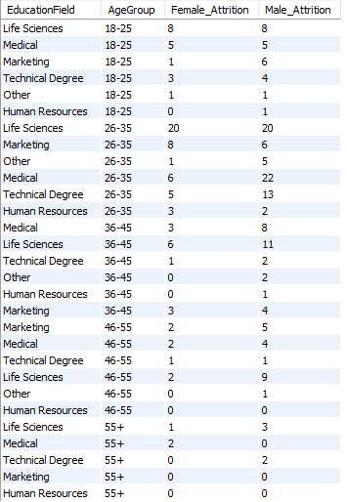GROUP BY EducationField, AgeGroup;

1. **Show total no of attrition with respect to job role and gender:**

select JobRole,

( select count(Attrition) from hr_analytics where Attrition='Yes' and Gender = 'Female' and JobRole= main.JobRole) as Female_Attrition,

( select count(Attrition) from hr_analytics where Attrition='Yes' and Gender = 'male' and JobRole= main.JobRole) as Male_Attrition,

( select count(Attrition) from hr_analytics where Attrition='Yes' and JobRole= main.JobRole) as Total_Attrition

from hr_analytics main

group by JobRole

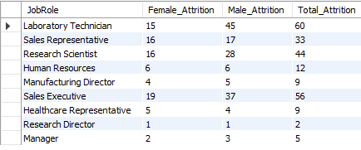

|  |  |
| --- | --- |
| 1. **Show total no of attrition with respect to job role and job satisfaction:**   select JobRole , JobSatisfaction , count(Attrition) AS Total_Attririon from hr_analytics  where Attrition='Yes'  group by JobRole , JobSatisfaction  Order by JobSatisfaction ASC     1. **Show max year at company:**   select max(YearsAtCompany) from hr_analytics  where Attrition='Yes' | 1. **Show total no of attrition with respect to Salary Slab:**   select salarySlab, count(attrition) AS Total_Attrition from hr_analytics  where Attrition='Yes'  group by SalarySlab     1. **Show total no of attrition with respect to Salary Slab and Over Time:**   select salarySlab,  ( select count(attrition) from hr_analytics where Attrition='Yes' and OverTime='Yes' and SalarySlab=main.SalarySlab) AS OverTime_Yes,  ( select count(attrition) from hr_analytics where Attrition='Yes' and OverTime='No' and SalarySlab=main.SalarySlab) AS OverTime_No,  ( select count(attrition) from hr_analytics where Attrition='Yes' and SalarySlab=main.SalarySlab) AS Total_Attrition  from hr_analytics main  group by SalarySlab     1. **Show the total attrition with respect to martial status:**   select MaritalStatus, Count(Attrition) AS Total_Attrition From hr_analytics  where Attrition='Yes'  group by MaritalStatus |